
SIMATS ENGINEERING
Saveetha Institute of Medical and Technical Sciences
Chennai-602105

September 2026

CSA0613– Design and Analysis of Algorithms

Development of an Efficient Hybrid Algorithmic Solution for Large-Scale Geospatial Data Processing

Assignment Report

Submitted by

TALARI VISHNUVARDHAN (192572091)
R Gautham Krishna (192421128)
Arun Balaji (192511075)

Assignment Information

Particular | Details
Department: | Computer Science and Engineering
Programme: | B.E./B.Tech. Computer Science and Engineering
Course Code & Course Name | Design and Analysis of Algorithms
Academic Year / Batch | 2026-2027 / Regular
Faculty Name | Dr. F. Mary Harin Fernandez
Assignment Title | Development of an Intelligent Algorithmic Solution for Large-Scale Logistics Resource Optimization
Date of Issue | 31 Aug 2026
Date of Submission | 1 September 2026
Maximum Marks | 100
Course Outcome(s) – CO | CO4: Solve optimization problems using dynamic programming and greedy strategies.
Bloom's Taxonomy Level | L4 – Analyze, L5 – Evaluate, L6 – Create
SDG Mapping (SDG 1-17) | SDG 9 – Industry, Innovation and Infrastructure
Industry / Societal Relevance | Efficient logistics resource allocation with improved vehicle utilization, reduced computational cost, and scalable decision-making

Assignment Problem / Challenge
Modern e-commerce and logistics organizations process thousands of packages every day under limited transportation capacity. Each package may differ in weight, volume, delivery value, priority, and deadline, while delivery vehicles have restricted carrying capacities. Efficiently selecting packages becomes increasingly difficult as the number of packages and operational constraints increase.
Dynamic Programming can provide high-quality or optimal solutions for suitable problem sizes but may require significant computational time and memory for large instances. Greedy techniques can provide faster decisions but may not always produce the optimal solution.
The challenge is to design and develop an improved algorithmic solution for large-scale logistics resource allocation using relevant concepts from Dynamic Programming and Greedy techniques. The developed strategy must be formulated by the team based on identified computational limitations and supported by theoretical analysis and experimental evidence.

Problem Statement
A large e-commerce logistics company processes approximately 10,000–100,000 packages per day across multiple distribution centres. Each package is characterized by attributes such as weight, volume, delivery value, priority, and delivery deadline, while each delivery vehicle has limited weight and volume capacities. During peak-demand periods, the organization must select an appropriate combination of packages for transportation so that the overall delivery benefit and

vehicle utilization are maximized without violating the available capacity constraints. Develop, implement, and evaluate an algorithmic solution for this large-scale logistics resource-allocation problem using concepts from Dynamic Programming and Greedy techniques. Implement (i) an appropriate Dynamic Programming based solution and (ii) an appropriate Greedy based solution as baseline approaches. Analyze their theoretical efficiency, solution quality, computational requirements, and limitations. Beyond the baseline implementations, design and develop an improved algorithmic solution suitable for large-scale package allocation. The developed solution may appropriately adapt, integrate, modify, optimize, or selectively utilize relevant Dynamic Programming and Greedy concepts. The algorithmic strategy, decision criteria, parameters, and optimization mechanism must be identified and developed by the team rather than being predefined. Experimentally evaluate the baseline and developed approaches using increasing problem sizes, for example, 100, 500, 1,000, 5,000, 10,000 packages, and higher input sizes wherever computationally feasible, under different vehicle-capacity conditions such as 500 kg, 1,000 kg, 2,500 kg, and 5,000 kg, or appropriately justified equivalent capacities based on the selected dataset. Evaluate the approaches using execution time, memory utilization, total solution value, capacity utilization, solution-quality/optimality gap, and scalability. Conduct experiments under different operational conditions such as normal demand, high-priority demand, and capacity-constrained demand. Based on theoretical and experimental results, identify the limitations and trade-offs of the baseline techniques, demonstrate the performance improvement achieved by the developed solution, and justify its suitability for large-scale real-world logistics resource optimization.

Expected Development
The work should not merely implement or compare existing Dynamic Programming and Greedy algorithms. The solution should demonstrate algorithmic development through:
  - Identification of computational and/or solution-quality limitations of the baseline approaches.
  - Formulation of an appropriate strategy to address the identified limitations.
  - Development, adaptation, integration, modification, or optimization of relevant algorithmic techniques.
  - Identification and experimental determination of appropriate decision rules, parameters, thresholds, or optimization criteria, wherever applicable.
  - Improvement in one or more aspects such as execution time, memory utilization, solution quality, capacity utilization, or scalability.
  - Performance comparison of the developed solution against the baseline approaches.
  - Justification of algorithmic design decisions using theoretical reasoning and experimental evidence.

Requirements and Constraints
The following requirements and constraints shall be considered:

Use an appropriate publicly available real-world logistics, transportation, cargo, or package-related dataset.
  - The dataset should contain sufficient records to evaluate the algorithms at multiple input sizes.
  - Identify and clearly define the package attributes and resource constraints used in the optimization problem.
  - Implement and evaluate suitable Dynamic Programming and Greedy baseline

approaches.
  - Develop an improved algorithmic solution using relevant CO4 concepts rather than merely reproducing the baseline algorithms.
  - The developed strategy must be designed and justified by the team.
  - Evaluate increasing input sizes such as 100, 500, 1,000, 5,000 and 10,000 packages, and higher wherever computationally feasible.
  - Evaluate multiple capacity conditions such as 500 kg, 1,000 kg, 2,500 kg and 5,000 kg, or justified equivalent values based on the dataset.

Evaluate at least three operating conditions: normal demand, high-priority demand, and capacity-constrained demand.
  - Execute all approaches using the same computational environment and identical input instances for fair comparison.
  - Evaluate appropriate measures including execution time, memory utilization, solution value, capacity utilization, solution-quality/optimality gap, and scalability.
  - Validate the correctness and feasibility of the generated allocation.
  - Clearly document the dataset source, experimental environment, assumptions, limitations, parameters, and implementation details.

Student Work

1. Problem Understanding and Formulation
1.1 Logistics Resource-Allocation Problem
Modern e-commerce and logistics organizations process thousands of packages every day. Each package may differ in weight, volume, delivery value, priority and delivery deadline, while delivery vehicles have limited carrying capacities. The logistics resource-allocation problem is to determine an appropriate combination of packages that maximizes overall delivery benefit and vehicle utilization without violating weight and volume constraints.
1.2 Real-World Significance
Improves vehicle capacity utilization.
Increases the total value of delivered packages.
Supports urgent and high-priority deliveries.
Reduces transportation resource wastage.
Supports faster decisions during peak demand.
Improves scalability for large logistics operations.
1.3 Dataset Description
A publicly available real-world logistics, transportation, cargo or package-related dataset will be used for implementation and experimentation. The selected dataset must contain sufficient records to evaluate multiple input sizes. Where a required optimization attribute is not directly available, a clearly documented and justified preprocessing or derivation method will be applied.
Attribute | Description
Package ID | Unique identifier for each package
Weight | Weight of the package in kilograms
Volume | Space occupied by the package
Delivery Value | Business benefit associated with delivery
Priority | Importance level of the package
Deadline | Delivery urgency or required delivery time
1.4 Resource Constraints
Each vehicle has limited weight and volume capacities. A package can be selected only when the resulting allocation remains feasible.
Weight constraint: Σ Wi xi ≤ Wmax
Volume constraint: Σ Vi xi ≤ Vmax
where xi = 1 if package i is selected and xi = 0 otherwise.
1.5 Expected Input and Output
Input includes package records, selected input size, vehicle weight capacity, vehicle volume capacity, operating condition and algorithm parameters. Output includes selected packages, total solution value, total weight and volume, capacity utilization, number of selected packages, execution time, memory utilization and feasibility status.
1.6 Optimization Objective
The primary objective is to maximize total delivery benefit:
Maximize Z = Σ Bi xi
subject to the weight and volume constraints. The developed approach additionally considers priority, deadline urgency and resource efficiency during package ranking.
1.7 Computational Challenges
The number of packages can increase from hundreds to tens of thousands.
Dynamic Programming may require substantial computation and memory.
Greedy methods are fast but can make locally optimal decisions that reduce overall solution quality.
Multiple package attributes and capacity constraints increase decision complexity.
Peak-demand conditions require fast and scalable allocation.
1.8 Assumptions, Requirements and Limitations
Each package is indivisible and can be selected at most once.
Weights and volumes are non-negative and validated before execution.
Vehicle capacities are fixed for each experiment.
All algorithms use identical input instances and the same computational environment.
Dynamic Programming is executed only where computationally feasible.
The proposed method depends on experimentally selected scoring parameters and candidate thresholds.
The initial model focuses on package allocation and does not fully model routing, traffic or multi-vehicle interactions.
2. Application of Course Knowledge
2.1 Dynamic Programming Formulation
Dynamic Programming is implemented as the baseline high-quality optimization approach using a 0/1 knapsack-style formulation. The algorithm evaluates whether including or excluding a package produces the better solution under the available capacity.
State: DP[i][w] represents the best achievable solution value using the first i packages under capacity w.
Recurrence: DP[i][w] = max(DP[i-1][w], Bi + DP[i-1][w-Wi]) when Wi ≤ w; otherwise DP[i][w] = DP[i-1][w].
Base condition: DP[0][w] = 0.
Solution construction is performed by tracing the decisions that produce the maximum value.
For the optimized one-dimensional implementation, the theoretical time complexity is O(nW) and space complexity is O(W), where n is the number of packages and W is the discretized weight capacity. Additional volume feasibility checks or justified transformations are applied in the implementation.
2.2 Greedy Technique
The Greedy baseline ranks packages using a transparent prioritization criterion and selects feasible packages in descending score order.
A basic efficiency criterion is Value/Weight. The implemented system can additionally include normalized priority, deadline urgency, weight efficiency and volume efficiency.
The sorting stage requires O(n log n) time and sequential feasibility checking requires approximately O(n), giving an overall complexity of O(n log n).
Advantages: fast execution, low computational requirements and high scalability.
Limitation: it does not guarantee a globally optimal allocation.
2.3 Contribution of CO4 Concepts to the Developed Solution
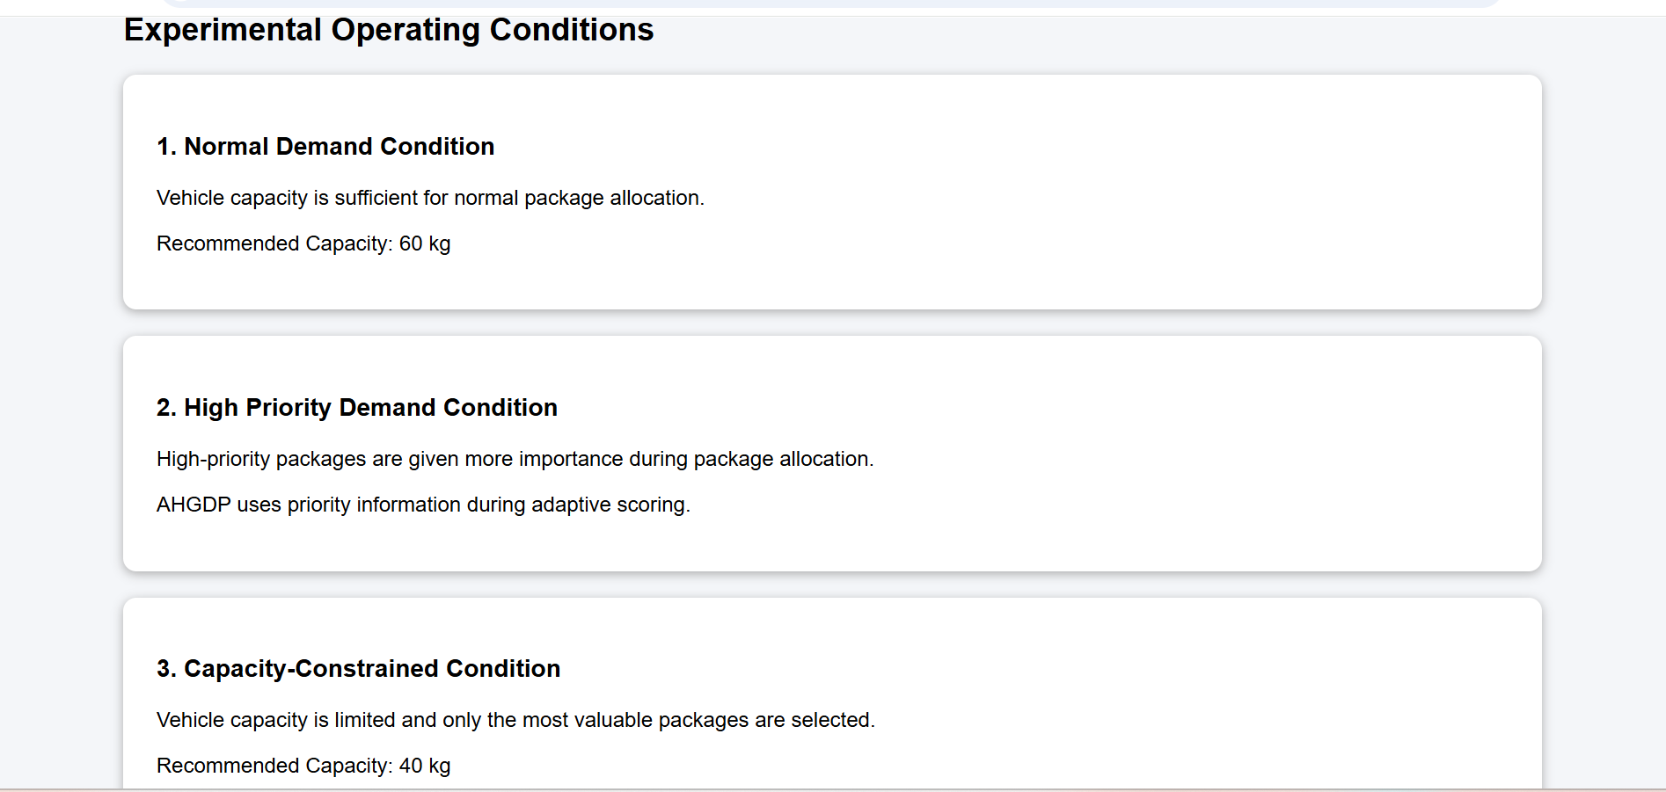

Dynamic Programming contributes high-quality optimization within a manageable candidate set. Greedy techniques contribute rapid ranking, candidate reduction and capacity filling. The developed strategy integrates these strengths to reduce the computational limitations of full Dynamic Programming while improving solution quality compared with a simple Greedy approach.
3. Solution / Design / Methodology
The methodology follows the required sequence:
Input Dataset → Data Preparation → Problem Formulation → DP Baseline → Greedy Baseline → Limitation Analysis → Proposed Solution Development → Implementation → Experimental Evaluation → Optimization → Performance Comparison → Final Decision
3.1 Developed Algorithm: AHGDP
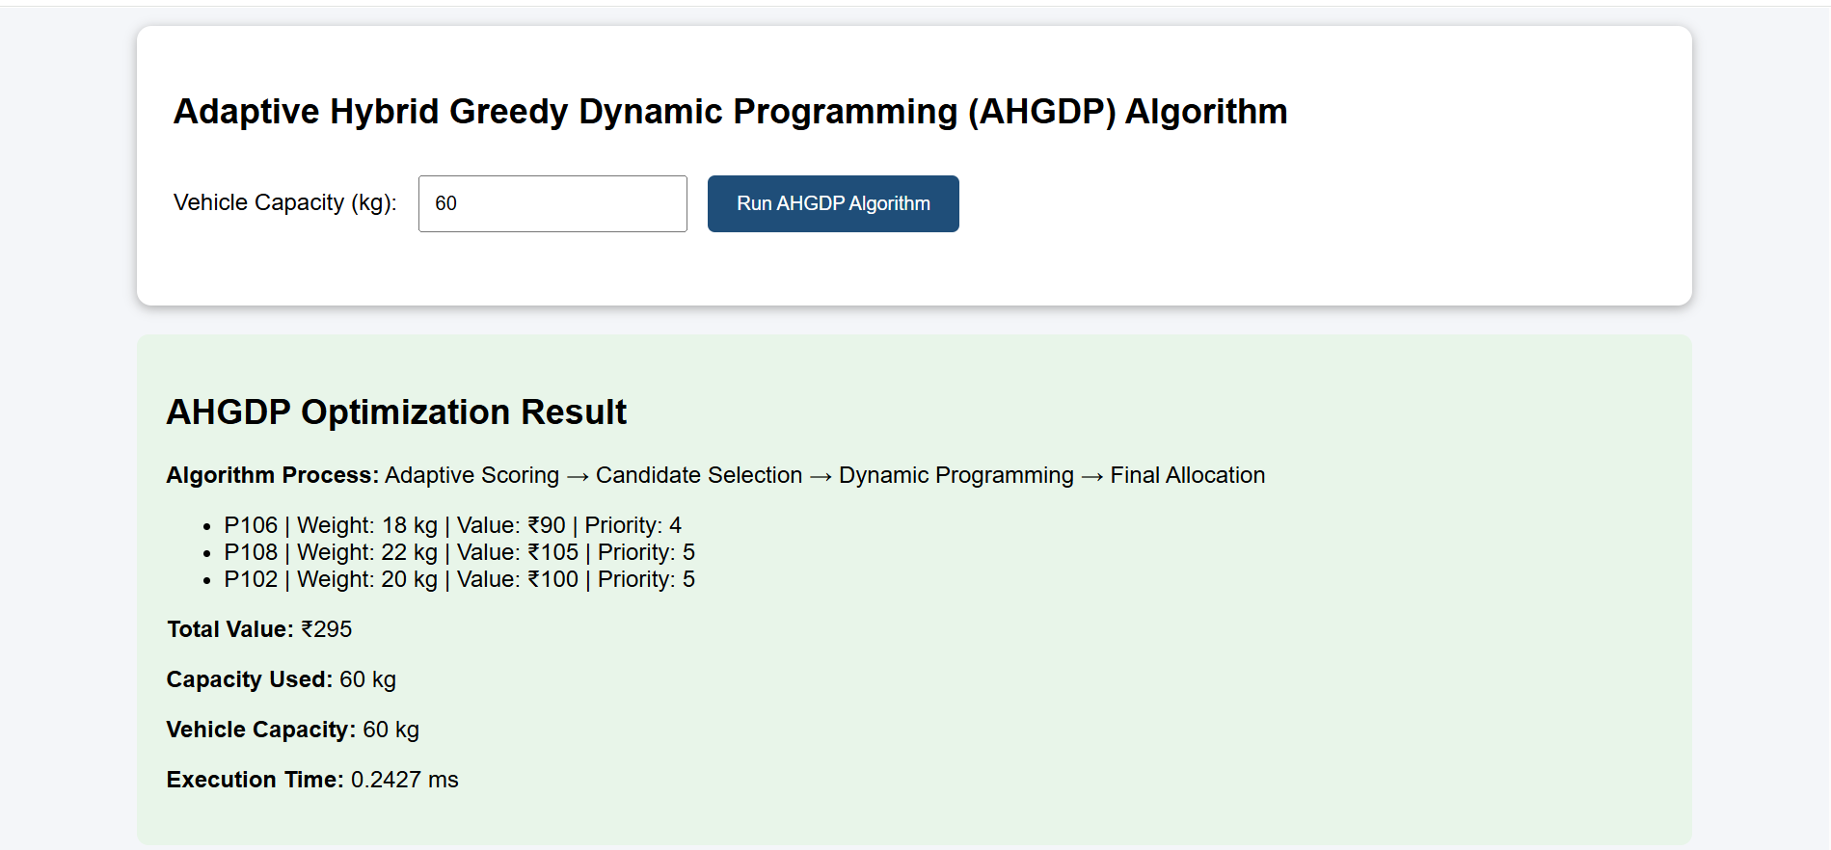
The proposed team-developed strategy is named AHGDP (Adaptive Hybrid Greedy-Dynamic Programming Algorithm). It combines adaptive multi-criteria scoring, Greedy candidate reduction, Dynamic Programming refinement and Greedy capacity filling.
3.2 Phase 1 – Data Preparation
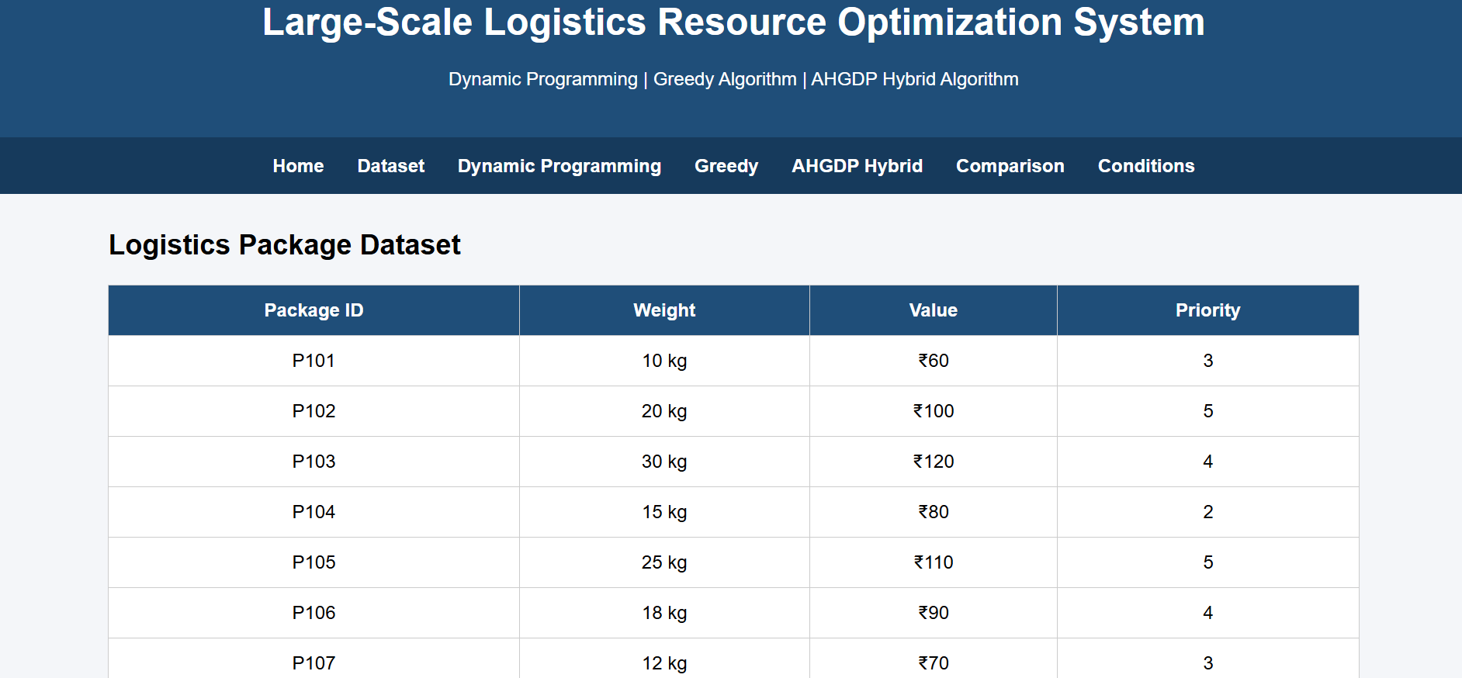
Validate required columns.
Detect missing and invalid values.
Reject negative weights and volumes.
Normalize attributes required for scoring.
Prepare identical input instances for fair experiments.
3.3 Phase 2 – Adaptive Scoring
Each package receives an Adaptive Score:
AdaptiveScorei = αVEi + βPFi + γDUi + δREi
VE = value efficiency, PF = priority factor, DU = deadline urgency and RE = resource efficiency. The parameters satisfy α + β + γ + δ = 1.
Operating Condition | α Value | β Priority | γ Deadline | δ Resource
Normal Demand | 0.40 | 0.25 | 0.20 | 0.15
High-Priority Demand | 0.25 | 0.45 | 0.20 | 0.10
Capacity-Constrained Demand | 0.35 | 0.20 | 0.15 | 0.30
3.4 Phase 3 – Greedy Candidate Reduction
All packages are ranked by Adaptive Score. Instead of applying Dynamic Programming to the entire large dataset, only the most promising candidates are retained. Candidate pool sizes such as Top 100, Top 250, Top 500, Top 1,000 or an adaptive percentage can be experimentally evaluated.
3.5 Phase 4 – Dynamic Programming Refinement
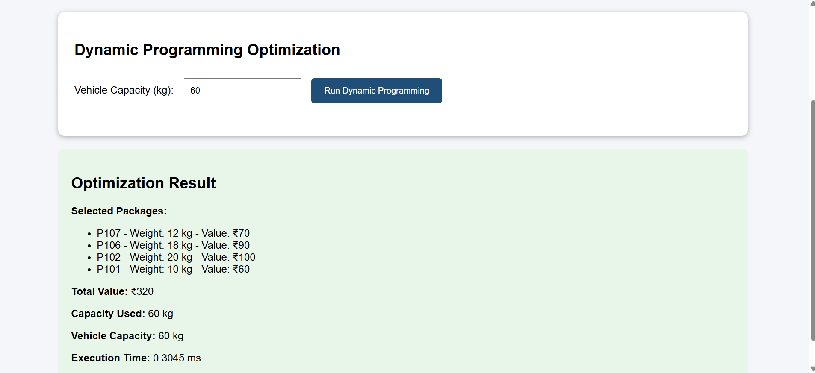
Dynamic Programming is applied to the reduced candidate pool to improve allocation quality while controlling computational requirements.
3.6 Phase 5 – Greedy Capacity Filling
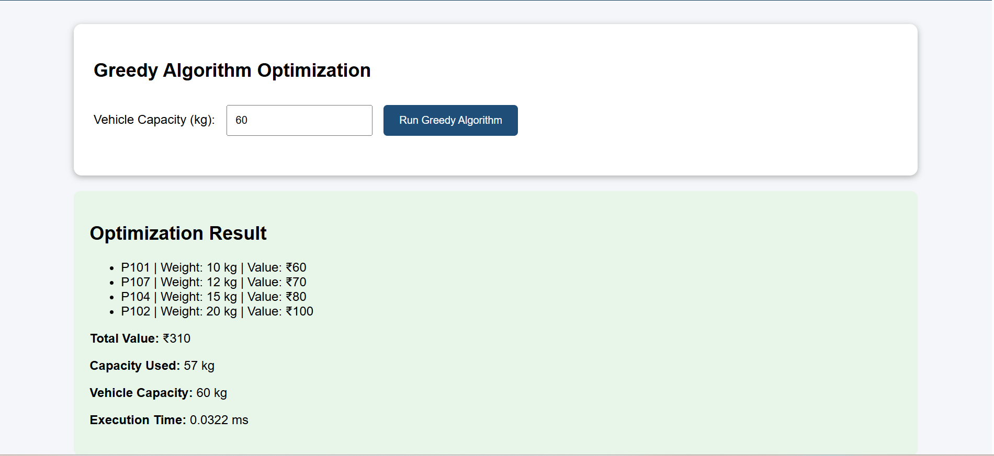
After Dynamic Programming refinement, remaining weight and volume capacities are calculated. Feasible unselected packages are ranked again and suitable packages are added until no further package can fit. This stage aims to improve vehicle utilization.
3.7 Dynamic Programming Pseudocode
DP_PACKAGE_SELECTION(packages, capacity)
initialize DP array
for each package:
update states from capacity down to package weight
choose the maximum feasible value
reconstruct selected packages
validate weight and volume constraints
return allocation and metrics
3.8 Greedy Pseudocode
GREEDY_SELECTION(packages, weightCapacity, volumeCapacity)
calculate score for every package
sort packages in descending score order
selectedPackages = empty
for each package:
if the package fits both constraints:
select package
return selectedPackages and metrics
3.9 AHGDP Pseudocode
AHGDP(packages, capacities, operatingCondition)
validate and preprocess dataset
select adaptive parameters
normalize attributes
calculate adaptive scores
sort packages by score
reduce to promising candidate pool
apply Dynamic Programming to candidates
calculate remaining capacities
rank feasible unselected packages
greedily fill remaining capacity
validate final allocation
return allocation and performance metrics
3.10 Flowchart of Developed Approach
START
↓
Load Dataset
↓
Validate and Prepare Data
↓
Select Operating Condition
↓
Calculate Adaptive Scores
↓
Greedy Ranking
↓
Candidate Reduction
↓
Dynamic Programming Refinement
↓
Check Remaining Capacity
↓
Greedy Capacity Filling
↓
Validate Allocation
↓
Display Results
↓
END
3.11 Mathematical and Complexity Analysis
DP baseline: O(nW) time and O(W) optimized space for the selected formulation. Greedy baseline: O(n log n) due to sorting. AHGDP includes O(n) scoring, O(n log n) ranking, reduced DP complexity O(kW), and additional linear or near-linear capacity filling, where k is much smaller than n. Therefore, the main design objective is to select k << n while retaining high-quality candidates.
4. Use of Modern Tools
Tool / Technology | Purpose
Python | Algorithm implementation
Pandas | Dataset processing and cleaning
NumPy | Numerical operations
Matplotlib | Performance graphs and visualizations
psutil / memory tools | Memory utilization measurement
time.perf_counter() | High-resolution execution-time measurement
Jupyter Notebook / Google Colab / VS Code | Development and experimentation
Web application platform | Interactive dataset, configuration and results dashboard
Implementation evidence will include source code, dataset source, experimental setup, execution outputs, result tables and graphs.
5. Results and Validation
5.1 Experimental Setup
The Dynamic Programming baseline, Greedy baseline and AHGDP developed solution will be evaluated using identical input instances in the same computational environment.
Input Size
100
500
1,000
5,000
10,000

Weight Capacity
500 kg
1,000 kg
2,500 kg
5,000 kg
5.2 Operating Conditions
Normal Demand – balanced value, priority, deadline and efficiency.
High-Priority Demand – increased importance for priority packages.
Capacity-Constrained Demand – increased importance for resource efficiency.
5.3 Evaluation Metrics
Execution time
Memory utilization
Total solution/delivery value
Weight and volume capacity utilization
Number of selected packages
Solution-quality / optimality gap
Input size
Scalability
Feasibility and correctness of allocation
Capacity Utilization (%) = Used Capacity / Maximum Capacity × 100
Optimality Gap (%) = (DP Reference Value − Algorithm Value) / DP Reference Value × 100, where DP is computationally feasible.
5.4 Validation Rules
Selected total weight must not exceed vehicle weight capacity.
Selected total volume must not exceed vehicle volume capacity.
No package may be selected more than once.
All selected records must contain valid attributes.
Every reported allocation must pass feasibility checks.
5.5 Results Presentation
Results will be presented using tables and graphs including Input Size vs Execution Time, Input Size vs Memory Utilization, Algorithm vs Total Solution Value, Capacity vs Utilization and Algorithm vs Optimality Gap. Actual measured values from experiments will be inserted into the final results tables.
6. Analysis and Engineering Decision
6.1 Comparison of Approaches
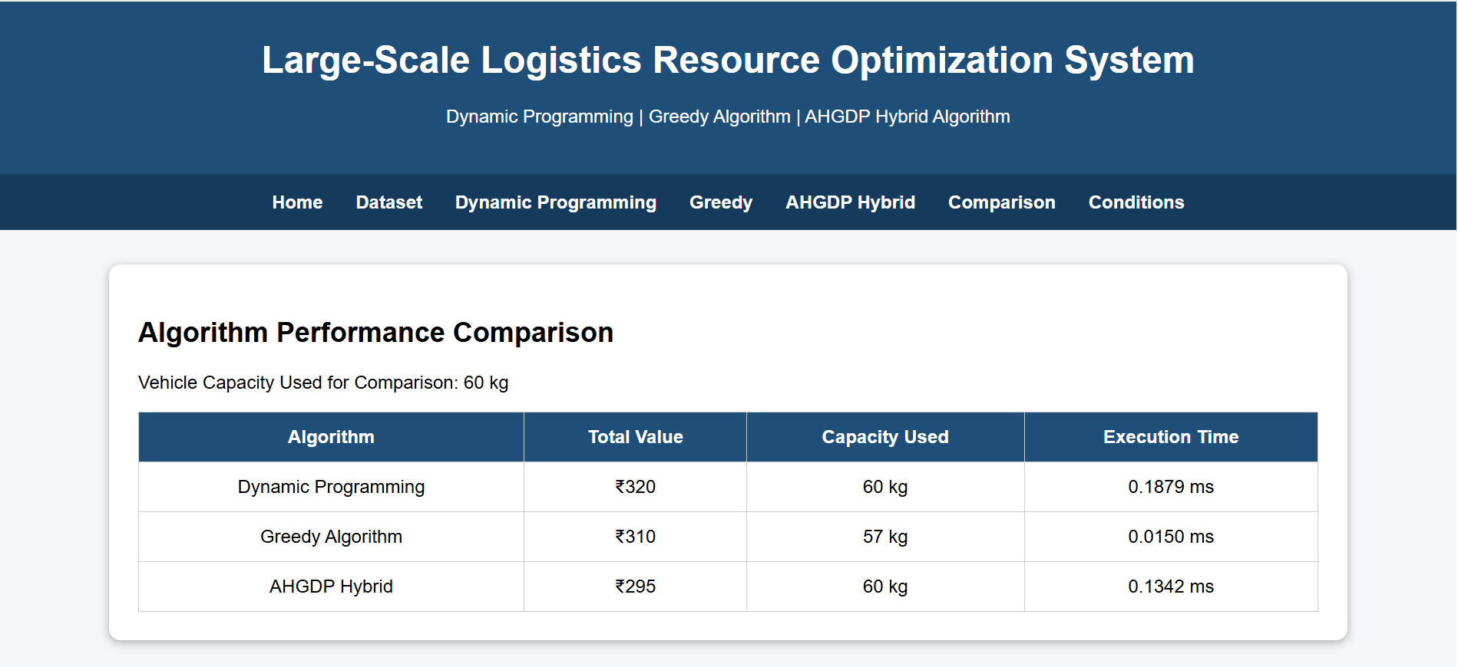

Approach | Strength | Main Limitation | Suitable Situation
Dynamic Programming | High-quality/optimal solution for feasible instances | High time and memory requirements | Small or moderate instances where quality is critical
Greedy | Very fast and scalable | May sacrifice global solution quality | Very large instances requiring rapid decisions
AHGDP | Balances scalability, quality and utilization | Depends on parameter and candidate selection | Large instances requiring better quality than simple Greedy
6.2 Trade-off Analysis
Dynamic Programming generally prioritizes solution quality at a higher computational cost. Greedy prioritizes execution speed and scalability but can produce lower-quality solutions. AHGDP is designed as an engineering compromise: Greedy methods reduce the search space, DP improves the quality of promising selections and the final Greedy stage attempts to utilize remaining capacity.
6.3 Final Engineering Decision
The final recommendation will be based on quantitative experimental evidence. Dynamic Programming will be recommended when the instance is computationally feasible and high-quality optimization is required. Greedy will be recommended for very large instances requiring immediate decisions. AHGDP will be recommended when the experiments demonstrate improved balance among execution time, solution value, capacity utilization and scalability.
7. Broader Considerations
The developed solution supports efficient transportation resource utilization by selecting packages according to benefit and resource constraints. Candidate reduction can reduce unnecessary computational expenditure, while capacity filling can improve vehicle utilization. The approach is designed to scale to larger datasets and can support practical logistics decision-making.
7.1 SDG 9 – Industry, Innovation and Infrastructure
The project contributes to SDG 9 by demonstrating algorithmic innovation for more efficient logistics infrastructure. It supports scalable industrial decision-making, improved transportation resource utilization, reduced operational waste and the development of intelligent technology-based logistics systems.

8. Conclusion
This project addresses large-scale logistics package allocation under limited vehicle weight and volume capacities. Dynamic Programming and Greedy techniques are implemented as baseline approaches. Dynamic Programming provides high-quality solutions for feasible sizes but faces computational limitations as the problem grows. Greedy methods are efficient and scalable but may not provide the best overall allocation.
To address these trade-offs, the Adaptive Hybrid Greedy-Dynamic Programming Algorithm (AHGDP) was developed. It combines adaptive scoring, Greedy candidate reduction, Dynamic Programming refinement and Greedy capacity filling. The final performance claims and best-performing conditions will be determined using measured experimental evidence across multiple input sizes, capacity conditions and operational scenarios.
Future work can investigate automatic parameter tuning, larger candidate pools, parallel processing, multi-vehicle allocation, route constraints and more advanced optimization techniques.
9. Student Reflection
9.1 What did you learn from developing an improved solution beyond implementing standard Dynamic Programming and Greedy algorithms?
I learned that solving a real-world optimization problem requires more than implementing standard algorithms. Dynamic Programming and Greedy methods have different strengths and limitations. By studying their computational behavior, I understood how algorithmic techniques can be adapted and integrated to create a more practical solution. The project also improved my understanding of scalability, computational cost, solution quality, parameter selection and experimental validation.
9.2 What computational or solution-quality limitations did you identify, and how did your developed approach address them?
The main limitation of Dynamic Programming was the increase in computational and memory requirements for large datasets. The Greedy approach was computationally efficient but could produce lower-quality solutions because it makes locally based decisions. AHGDP addresses these limitations by using adaptive Greedy ranking to reduce the candidate set before applying Dynamic Programming. A final Greedy capacity-filling stage attempts to improve utilization of remaining resources.
9.3 If additional computational resources or time were available, how would you further improve your solution and why?
With additional computational resources, I would evaluate larger candidate pools, automatic parameter tuning, parallel processing and multi-vehicle optimization. I would also test more operational conditions and richer real-world constraints such as route distance and delivery time. These improvements could improve solution quality and practical applicability.

9.4 How can the developed solution contribute to SDG 9 – Industry, Innovation and Infrastructure?
The developed solution contributes to SDG 9 by supporting intelligent and scalable logistics infrastructure. Efficient allocation can improve transportation resource utilization, reduce computational and operational waste and support technology-driven industrial decision-making. The project demonstrates how algorithmic innovation can be applied to improve real-world infrastructure and logistics operations.
10. References
The final report should include the exact references for the selected public dataset, algorithm literature, software documentation and external resources actually used during implementation.
Dataset source: Insert the official citation and access details of the selected publicly available logistics/transportation dataset.
Dynamic Programming and 0/1 Knapsack literature consulted for the baseline formulation.
Greedy algorithm literature consulted for selection and complexity analysis.
Python Software Foundation documentation.
Pandas documentation.
NumPy documentation.
Matplotlib documentation.
psutil documentation, if used for memory measurement.
Any web development tools or platforms used for the interactive application.
AI-assisted tools used during development and documentation, where disclosure is required by institutional policy.

Assessment Rubric

Criteria | Max Marks | Excellent | Good | Satisfactory | Needs Improvement

Problem Understandin g &  Algorithmic Formulation | 10 | Clearly identifies the problem, requirements, inputs, outputs,  constraints and computational challenges and  formulates them appropriately for solution development. | Problem and major  requirements are correctly formulated with minor gaps. | Basic formulation is provided, but requirements or constraints are partially identified. | Problem is poorly understood or inadequately formulated.
Algorithmic Solution Design | 15 | Designs a clear, logical and feasible solution strategy with appropriate algorithmic techniques, pseudocode/flowchart and well-justified design decisions. | Appropriate solution design with minor gaps in logic, representatio n or  justification. | Basic solution design is presented but lacks  completeness or clear justification. | Solution design is  inappropriate  , incomplete or unclear.
Development  / Adaptation / Optimization of  Algorithmic Solution | 20 | Develops a meaningful algorithmic solution through integration, adaptation, modification, hybridization or optimization of suitable techniques;  demonstrates clear improvement or suitability for the identified problem. | Develops an appropriate solution with meaningful adaptation or improvement  , with minor limitations. | Solution  demonstrates limited adaptation or development beyond standard implementati on. | Merely  reproduces an existing algorithm with little or no meaningful development or adaptation.
Implementati on & Modern Tool Usage | 15 | Developed solution is correctly and efficiently implemented using  appropriate programming/computati onal tools and handles relevant input conditions reliably. | Implementati on is functional with minor logical or efficiency issues. | Core implementati on works but contains  limitations or incomplete functionality. | Implementati on is incomplete, unreliable or non-function al.
Efficiency, Testing & Validation | 15 | Performs appropriate complexity evaluation and systematic testing using suitable data/input sizes; validates correctness, efficiency and scalability with  clear evidence. | Complexity evaluation and testing are mostly appropriate with minor gaps. | Basic testing and efficiency evaluation are provided but lack sufficient validation. | Testing, complexity evaluation or validation is inadequate or substantially incorrect.
Performance Improvement  , Comparison & Final Decision | 15 | Demonstrates the effectiveness of the developed solution through appropriate  comparison; critically evaluates performance, | Good  performance comparison and justification | Basic comparison is provided, but improvement or final | Improvement is not demonstrated or the final  algorithmic

 |  | limitations and  trade-offs and justifies the final algorithmic decision with evidence. | with minor limitations. | justification lacks depth. | decision is unsupported.
Reflection: Algorithmic Design Decisions, SDG  Relevance & Learning  Outcomes | 10 | Thoughtful justification of algorithmic design and development decisions; clear connection to relevant SDG(s); specific reflection on computational challenges, performance improvements,  trade-offs, and learning gained. | Appropriate justification of  algorithmic decisions; SDG  relevance, challenges, improvement s, and learning are discussed but lack depth. | Reflection is present but generic; limited justification of algorithmic decisions,  improvements  , SDG  relevance, or learning outcomes. | No genuine reflection is provided, or the reflection lacks meaningful connection to algorithm development, SDG  relevance, challenges, or learning outcomes.
Total | 100

CO–PO–Assessment Mapping

Assessment Component | CO | PO(s) | Bloom's Level | Marks

Problem Understanding & Algorithmic Formulation | CO4 | PO1, PO2 | L4 | 10
Algorithmic Solution Design | CO4 | PO2, PO3 | L4, L6 | 15
Development / Adaptation / Optimization of Algorithmic Solution | CO4 | PO2, PO3 | L5, L6 | 20
Implementation & Modern Tool Usage | CO4 | PO3, PO5 | L4, L6 | 15
Efficiency, Testing & Validation | CO4 | PO2, PO4 | L4, L5 | 15
Performance Improvement, Comparison & Final Decision | CO4 | PO2, PO4 | L4, L5 | 15
Reflection: Algorithmic Design Decisions, SDG Relevance & Learning Outcomes | CO4 | PO7, PO10, PO12 | L4, L5 | 10

Faculty Evaluation & Continuous Improvement
CO Attainment

Performance Level | Criterion
Level 3 | ≥ 70%
Level 2 | 60–69%
Level 1 | 50–59%
Level 0 | < 50%
Target CO Attainment: Actual CO Attainment: Faculty Analysis
Areas in which students performed well:

Areas requiring improvement:

Corrective / Improvement Action:

